“Dedicated to Serving Youth and Families in the Community”

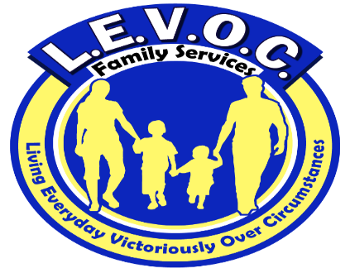

L.E.V.O.C. Family Services location

3210 Academy Avenue

Portsmouth, Va. 2370

**Phone** 757-337-0689

**Fax** 1-866-719-9383

**www.levocfs.com**

L.E.V.O.C. OFFERS EACH INDIVIDUAL**:**

**H**elp to overcome obstacles hindering their growth and success

**O**ptimism that change is possible and obtainable

**P**lan to achieve and establish goals

**E**ncouragement to never give up!

L.E.V.O.C. = HOPE

Living Everyday Victoriously Over Circumstances

**\*\*Psychosocial Rehabilitation Services are provided at our Portsmouth location**

**Other services L.E.V.O.C. offers include intensive-in-home counseling, mental health skill-building services and substance abuse counseling.**

FUNDING FOR SERVICES

* Virginia Medicaid/Magellan
* FAMIS
* CSA
* Self-Pay

Enter Contact Information Here | 1127 Lombard Blvd. San Francisco, CA 59802 | phone 555.555.5555 | fax 555.555.5555

s

l.e.v.o.c.’s sERVICE AREAS INCLUDE:

Chesapeake

Emporia

Franklin

Hampton

Isle of Wight

Newport News

Norfolk

Petersburg

Portsmouth

Richmond

Suffolk

Southampton County

Surry

Virginia Beach

Psychosocial Rehabilitation Services

PSR

Psychosocial rehabilitation is a facility-based service designed to help individuals with severe and/or persistent mental illnesses and/or intellectual disabilities to develop social skills, vocational and daily living skills to achieve and maintain their optimal level of independence in the community.

Services

L.E.V.O.C. FAMILY SERVICES (LFS)

**L**.E.V.O.C. Family Services provides community-based services in the Commonwealth of Virginia. These services are comprehensive in nature and practical in their approach.

**E**ach client receives a comprehensive assessment and strengths-based, individualized, service plan that addresses his or her needs.

**V**ested in the communities it serves, L.E.V.O.C. works collaboratively with other community agencies and links clients to available community resources.

**O**perating in compliance with federal and state regulations governing mental health services, L.E.V.O.C. maintains the confidentiality and protects the rights & privacy of the clients we serve. L.E.V.O.C. is a member of several local Human Rights Committees.

**C**aring and competent mental health professionals work diligently to help clients achieve established goals and improve their quality of life.



What are Psychosocial Rehabilitative Services?

Psychosocial rehabilitation (PSR) is the process of restoration of community functioning and well-being of an individual who has a psychiatric disability.

The goal of PSR is to help individuals with persistent and serious mental health issues to develop the emotional, social and intellectual skills needed to live, learn, and work in the community with the least amount of professional support.

PSR helps individuals grow beyond the effects of mental health illness. It is a recovery process that helps improve one’s quality of life through focusing on the strengths and potential of the individual. The overall goal of PSR is to restore hope to people who have experienced major setbacks in their ability to function because of their mental illness.

Who can benefit from psychosocial rehabilitative services?

Individuals who may have experienced repeated psychiatric hospitalizations, lack daily living skills and have limited or non-existent support systems can benefit for psychosocial rehabilitative services. The services are intended to help participants function and remain stable in the community.

What do psychosocial rehabilitation participants receive?

* Training on effective strategies to manage their mental/behavioral health conditions
* Opportunity to develop and practice daily living skills
* Support and guidance to identify and apply for employment that accommodates their level of functioning
* Connection to resources, activities, and volunteer opportunities in the community
* A supportive environment in which to make friends, build self-esteem, and become productive citizens